 | Wilderness  First Aid  2-Day WFA Certification Course
 | ____________
Dec 8&9, 2018
8:00 AM to 5:00 PM

North Mountain Visitor Center
12950 N. 7th St., Phoenix, Az

For additional info, e-mail
WildernessMedicine@cox.net
or call
Mike Englund (623) 692-1908

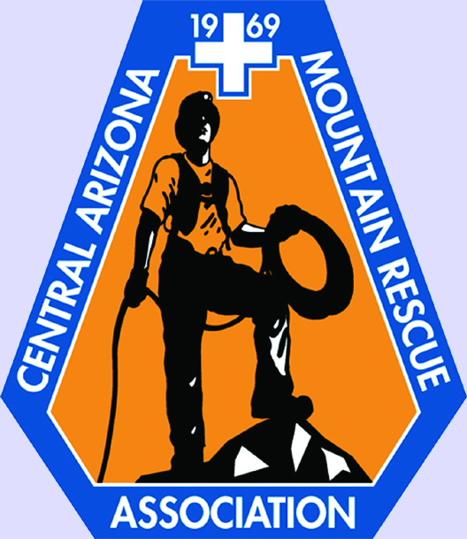

www.soloschools.com

